**Open Ended Experiment Report**

**On**

**Effects of Pre-emphasis of an Input Signal**

***Communication Engineering Laboratory (EC29002)***

**Submitted by**

**Anubrata Mukhopadhyay (2230311)**



**B.Tech in Electronics and Computer Science Engineering**

**School of Electronics Engineering**

**Kalinga Institute of Industrial Technology Deemed to be University**

**Bhubaneswar, India**

**November 2024**

**Aim of the Experiment :** To observe the effects of pre-emphasis on a given input signal.

**Components Required :**

| NAME | SPECIFICATION | QUANTITY |
| --- | --- | --- |
| Transistor (BC 107) | ft = 300MHz  Pd = 1W  Ic(max) = 100mA | 1 |
| Resistors | 10 KΩ, 7.5 KΩ, 6.8 KΩ | 1 each |
| Capacitors | 10 nF  0.1 µF | 1  2 |
| CRO | 20 MHz | 1 |
| Function Generator | 1 MHz | 1 |
| Regulated Power Supply | 0-30 V, 1 A | 1 |

**THEORY :** The presence of noise is also an issue in FM and we know that noise usually has higher amplitude and higher frequency. When the amplitude of a high-frequency noise is higher than the current component in the modulation signal, it causes high-frequency interference. To deal with this issue, most FM circuits use a technique called pre-emphasis during transmission and de-emphasis during receiving. Pre-emphasis and de-emphasis circuits are commonly used in FM transmitters and receivers to improve the output signal-to-noise ratio. Pre-emphasis and De-emphasis are used to improve the fidelity of [FM transmission](https://www.geeksforgeeks.org/frequency-modulation/) of the audio signal.

**CIRCUIT DIAGRAM :**

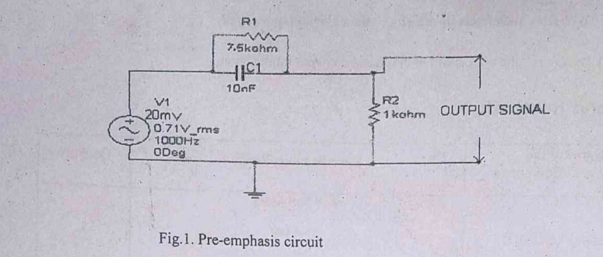

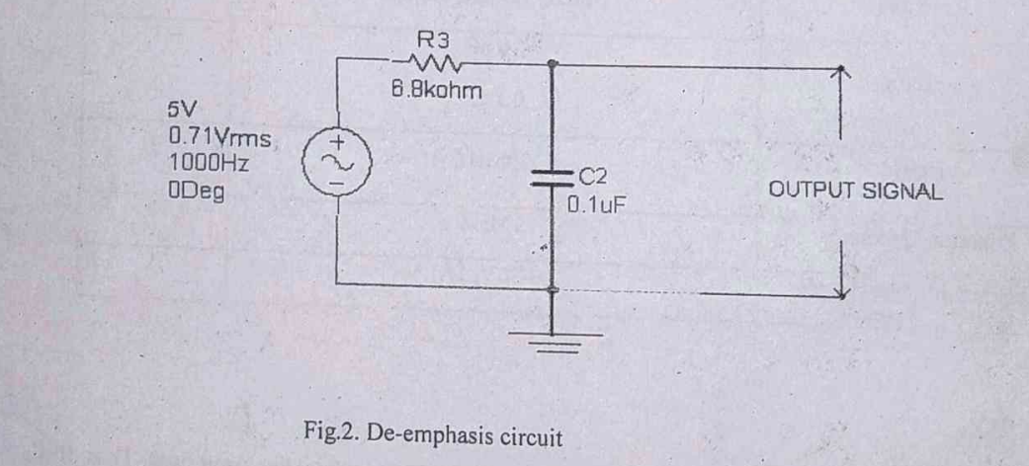

**PROCEDURE :** 1. Connect the circuit as per circuit diagram as shown in Fig.1.

2.Apply the sinusoidal signal of amplitude 20mV as input signal to pre-emphasis circuit.

3. Then by increasing the input signal frequency from 500 Hz to 20KHz, observe the output voltage (vo​) and calculate gain (20 log (vo​/vi​)).

4. Plot the graph between gain Vs frequency.

**SAMPLE READINGS :**

Table 1 : Pre-emphasis (Vi = 20mV)

| **Frequency** | **Vo (in mV)** | **Gain in dB** |
| --- | --- | --- |
| 500 Hz | 20 | 0 |
| 1 KHz | 30 | 3.52 |
| 2 KHz | 40 | 6.02 |
| 3 KHz | 50 | 7.96 |
| 4 KHz | 65 | 10.23 |
| 6 KHz | 80 | 12.04 |
| 8 KHz | 95 | 13.52 |
| 12 KHz | 115 | 15.21 |
| 16 KHz | 130 | 16.26 |
| 20 KHz | 145 | 17.22 |

**PLOT :**

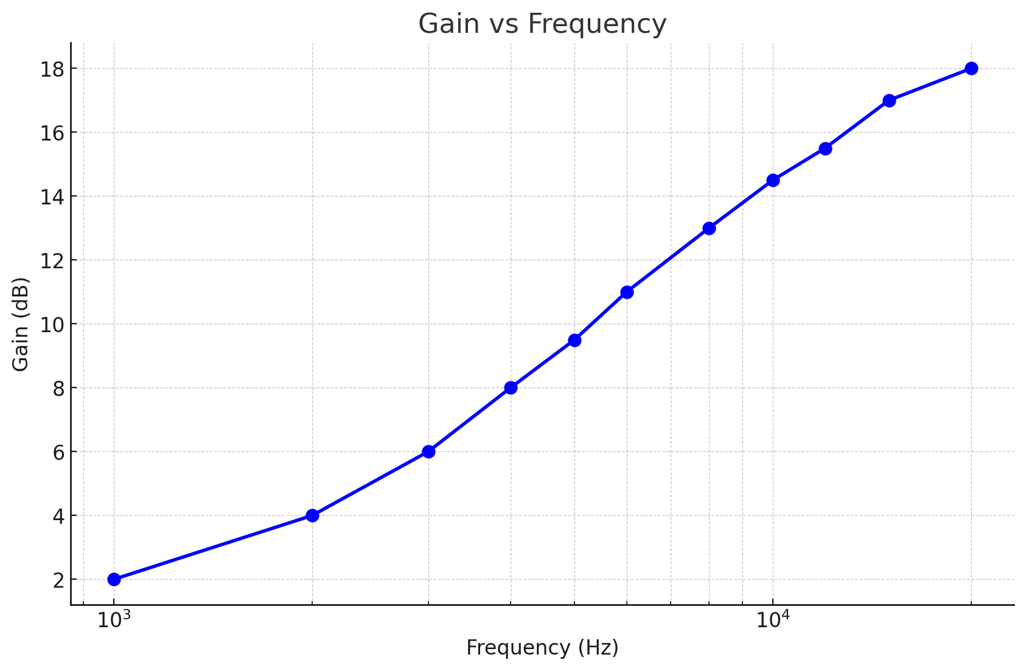

**BREADBOARD CONNECTIONS :**

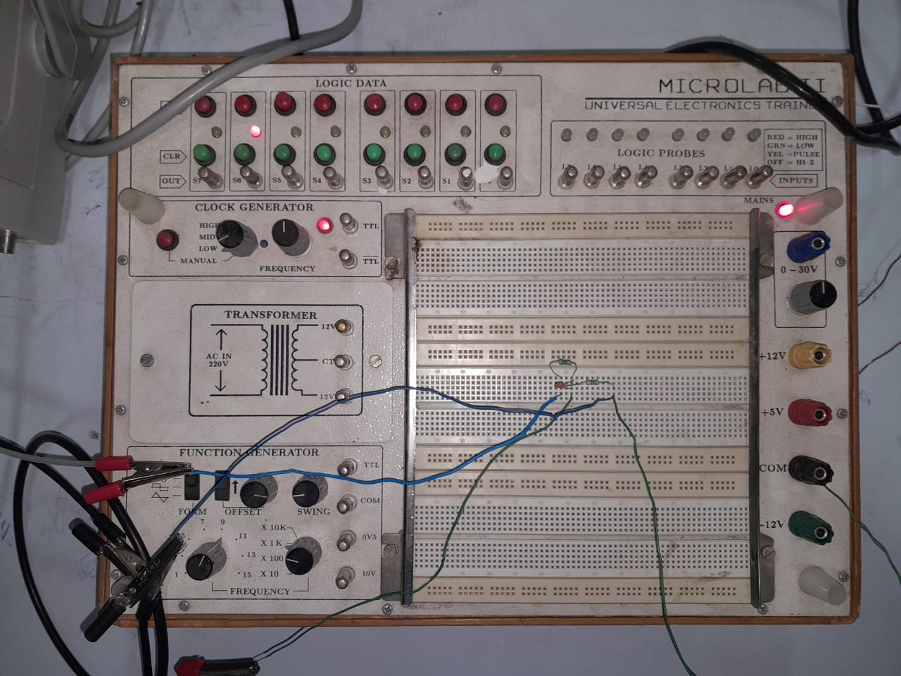

**INPUT SIGNAL :**

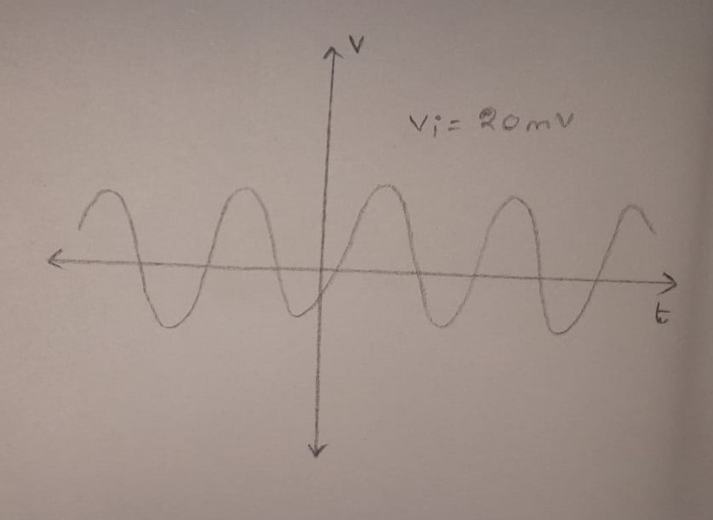

**PRECAUTIONS :**

1. Check the connections before giving the power supply.
2. Observations should be made carefully.

**CONCLUSION :**

Pre-emphasis was performed successfully on an input signal of 20 mV and ten different readings were taken for different frequencies of the input signal. The graph for pre-emphasis was created based on these values, which showed an increase in gain with increase in frequency of input signal.